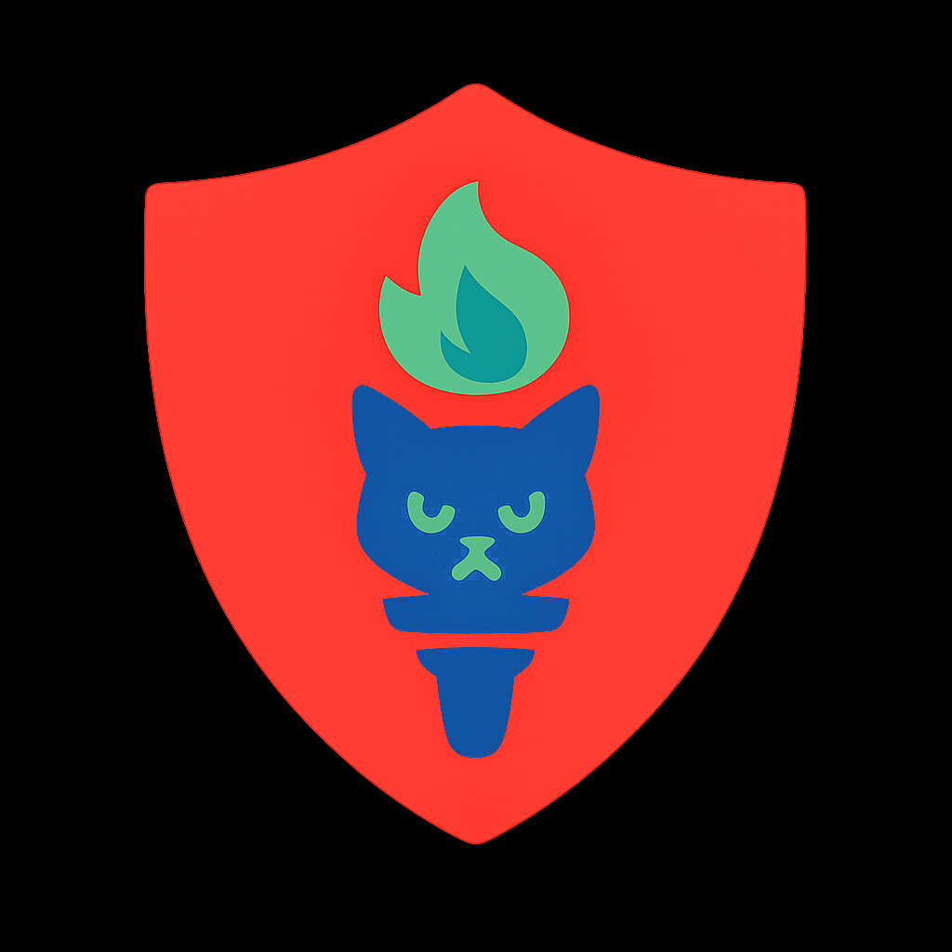 Vision & Contributor Agreement: GroupBuild
TL;DR: List shared intentions, guiding principles, collaboration terms, for team engaged in distributed development and civic mission of GroupBuild.

1. [OUR MISSION] — GroupBuild helps social communities self-organize to defend Democracy, dignity, and distributive justice. Our platform:
- Protects user anonymity while enabling accountable public discourse
- Supports peaceful protests, civic organizing, and whistle-blower protection
- Counteracts mass manipulation through AI-stack-audited content tagging and ethical moderation
- Offers distributed, trust-calibrated governance tools outside traditional institutions

2. [OUR PHILOSOPHY] — We believe no single entity should control access to Democracy, all ethical beings deserve voice and vote. Therefore:
- Code contributions serve the public good, not private shareholders
- Anonymous users earn reputations (RepTags), fosters ethical intent and reduces targetted coercion (political or commercial)
- Decisions evolve collaboratively via meritocratic voting and real-time participatory processes
- Multi-domain, cross-checking AI's form a moderator stack, using evolving metrics, not a master

3. [WHO YOU ARE] — You may be a student, activist, engineer, artist, or veteran organizer. What matters is your willingness to:
- Learn openly and collaborate respectfully
- Prioritize public interest over personal gain
- Engage in ethical development practices
- Work with imperfect tools for a better future

3. [OWNERSHIP & IP] — GroupBuild is a non-hierarchical, distributed project.

We are a non-hierarchical, distributed project, operating in the Americas, Europe and Asia, with servers hosted in safe havens, a default legal presence in Canada, and a beta-launch planned for the US in Q4 2025. Ownership is shared among volunteer Contributors, but nearly all project assets are open-source and thus belong to humanity. Financial speculation is not feasible because ownership means expense-sharing not income. However, by contributing for at least a year, you will be respectfully-offered ownership options, and for the next few years, co-founder status. Together with, and perhaps despite, these dubious offerings, you agree that:
- Your contributions are voluntary, provided under shared open license (version signed, but evolve-able)
- You retain moral authorship, but grant irrevocable rights to reuse, adapt, and improve your work
- You will not seek private compensation or ownership rights without full consent of the Contributor circle
- You will support future governance transitions as decided by the collective

4. [CONFIDENTIALITY & INTEGRITY] — Some discussions, data, strategies and security-related software must remain confidential. You agree to:
- Protect any sensitive information shared with you
- Avoid sharing internal communications unless clearly marked public
- Refrain from using GroupBuild assets or channels to promote personal agendas unrelated to our mission
- Disengage peacefully if your alignment or availability changes

5. [WORKING TOGETHER] — Our Contributor circle functions through trust, transparency, and shared purpose. You are encouraged to:
- Propose improvements and flag ethical concerns early
- Respect community moderation protocols and safe collaboration spaces
- Document your work clearly for others to build upon
- Ask for help, offer help, and leave the ladder down
- Never dox without their recorded consent, especially those in repressive regimes

6. [YOUR COMMITMENT] — By joining us, you affirm your intent to contribute with honesty, humility, and respect.

You are not required to agree with every principle, in fact you are encouraged to disagree, but you are expected to:
- Honor the values of distributed agency, informed consent, and civic empowerment
- Accept feedback and evolve your contributions with peer review
- Work toward a vision where the tools of power belong to “We The People”

7. [This is a living agreement]
Questions, amendments, or new proposals can be raised via the contributor forum, or directly with existing stewards. Our goal is not bureaucracy — but shared protection of something precious. GroupBuild Contact: Rick Ballard | +1.416.414.8100 | rick@GroupBuild.org | Bio and Publications
Agreed By (Volunteer Contributor): Name______________________________ Signature_______________________ Date____________________

